School of Computing, Creative Technologies, and Engineering 2021/22
Level 6 Production Project
MEETING RECORD SHEET: |  |  | Meeting  Number: 5
Student: Anupam Siwakoti |  | Student I.D.: C7227267
Date of Meeting: March 21st, 2022 |  | Supervisor: Resham Bdr Pun
Actions agreed at previous meeting (completed or comment):
1 | Learned about hexagonal architecture ¨
2 | Started implementing hexagonal architecture with spring ¨
3 | ¨
4 | ¨
5 | ¨
6 | ¨
Comments of student (if any):
This was the fifth meeting with our supervisor, he said to continue it.

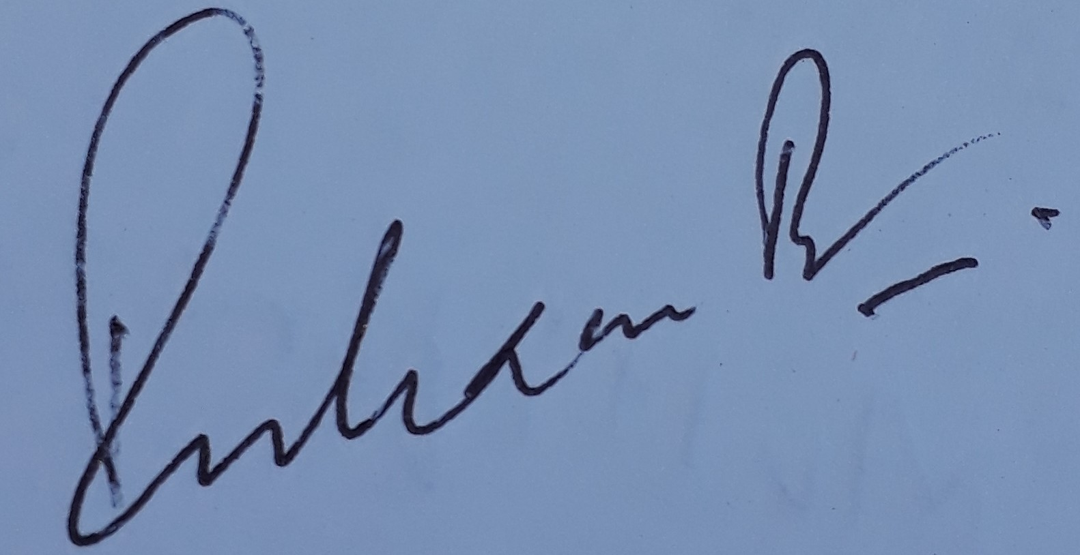
ABOVE here – student to complete before Meeting with supervisor. BELOW here – complete at the Meeting.
Next meeting (date/time): March 27th, 2022
Agreed Actions to complete before next meeting:
1 | Complete implementation of hexagonal architecture
2 | If possible, start implementation of CQRS and Event sourcing
3
4
5
6
Comments of supervisor (if any):
Continuous progress on his prototype

